126* How can I track the access on my S3 bucket?

•Use Amazon S3 server access logging to see information about requests to your buckets and objects. You can use Amazon Athena to analyze your server access logs.

•Use AWS CloudTrail to track API calls to your Amazon S3 resources. You can also use Athena to query your CloudTrail logs.

127* For what purpose cloudtrail is used?

You can use CloudTrail to view, search, download, archive, analyze, and respond to account activity across your AWS infrastructure. You can identify who or what took which action, what resources were acted upon, when the event occurred, and other details to help you analyze and respond to activity in your AWS account.

128* I have an instance n db connected to this instance is on prem. how can I connect my application to on prem database.

129* How will u connect aws with on prem database?

AWS Direct Connect is a network service that provides an alternative to using the Internet to utilize AWS cloud services. AWS Direct Connect enables customers to have low latency, secure and private connections to AWS for workloads which require higher speed or lower latency than the internet.

AWS Direct Connect does not involve the Internet; instead, it uses dedicated, private network connections between your intranet and Amazon VPC. Customers can also implement additional security controls by encrypting the traffic that rides the direct connections using similar protocols like SSL, HTTPs and SSH.

Q. How can I get started with AWS Direct Connect?

Use the AWS Direct Connect tab on the [AWS Management Console](https://console.aws.amazon.com/console/home) to create a new connection. Then you will change the region to the region you wish to use. When requesting a connection, you will be asked to select the AWS Direct Connect location you wish to use, the number of ports, and the port speed. You will also have the opportunity to request to have an APN Partner contact you if you need assistance extending your office or data center network to the AWS Direct Connect location.

[Frequently Asked Questions (amazon.com)](https://aws.amazon.com/getting-started/hands-on/connect-data-center-to-aws/faq/)

130* nacl & security group

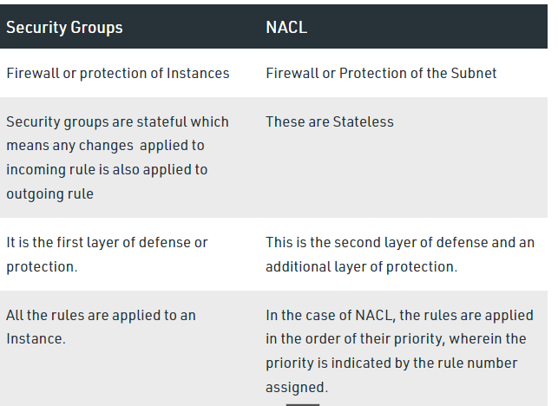

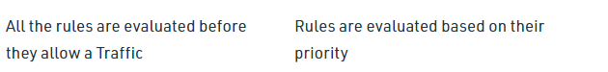

131* nacl will be having inbound & outbound.. is it any configuration have to do manually

132* traffic flow from NAT gateway to IGW

133* traffic flow how cross NACL, SECURITY GROUP, NAT gateway

134* Why NAT gateway why we cant NAT instance?

In short, NAT instances are on their way out of regular use. Gateways were specifically designed to replace them and be easier to use.

135* In aws, i have an instance which is critical machine that cant go down and its reaching 100% cpu utilisation.

It can be done by**creating an autoscaling group** to deploy more instances when the CPU utilization exceeds 100 percent and distributing traffic among instances by creating a load balancer and registering the Amazon EC2 instances with it.

136* what are the steps that u r going to take to save this machine from going down?

137* where u involved in the production release of ur application? are u deploying any application

138* what is the deployment strategy that is used in ur company and other stratgies that u know?

We were using blue green deployment

* Ramped. ...
* Blue/Green. ...
* Canary. ...
* A/B testing. ...

139* How you will spin up VPC

140* How you were using cloudwatch?

Amazon CloudWatch monitors your Amazon Web Services (AWS) resources and the applications you run on AWS in real time. You can use CloudWatch to collect and track metrics, which are variables you can measure for your resources and applications.

You can create alarms that watch metrics and send notifications or automatically make changes to the resources you are monitoring when a threshold is breached. For example, you can monitor the CPU usage and disk reads and writes of your Amazon EC2 instances and then use that data to determine whether you should launch additional instances to handle increased load. You can also use this data to stop under-used instances to save money.

141* Services used in AWS ?

1. Amazon EC2 2. Amazon RDS 3. Amazon S3 4. Amazon Lambda 5. Amazon CloudFront 6. Amazon Glacier 7. Amazon SNS 8. Amazon EBS 9. Amazon VPC 10. Amazon Kinesis 11. Amazon Auto-scaling 12. Amazon IAM 13. Amazon SQS

142* How can you make any S3 bucket as private ?

143* Cross region replication ? how you apply it ? will it copy automatically ?

144* S3 transfer accereration ?

* Go to the Amazon S3 Console, and click on the bucket name for which you wish to enable the transfer acceleration. Click on the ‘properties’ and choose ‘Transfer acceleration’. ...
* REST API can be used to enable transfer acceleration,
* AWS CLI and AWS SDK can be used to enable transfer acceleration.

**What is Amazon Transfer Acceleration - Key features**

It is a service facilitated by Amazed that helps in quick, easy and secure transfer of files between one client and an S3 bucket. The distance between the client and S3 is usually large. Transfer Acceleration leverages Amazon’s CloudFront’s globally distributed edge locations to transfer files quickly. When data arrives to an edge location, it is routed to the Amazon S3 service via an optimized network path. When Transfer acceleration service is used, extra charges are incurred by the user.

145* Read replica ?

The read replica operates as a DB instance that allows only read-only connections. Applications connect to a read replica the same way they do to any DB instance. Amazon RDS replicates all databases in the source DB instance.

146* Suppose I have 1 master and 2 replicas, master crashes and what will happen to replication ?

147* In case there is only one master and fails, application runs or failure ?

148* Suppose you create Auto scaling group and in launch conf you specify as 3 instances, then the all the 3 instances are running in full capacity ? will the applciation fails or it will be running ? Do you think AWS will provide new instance ?

149* How do you manage credentials ?

150* If credentials icon is not available? What you will do?